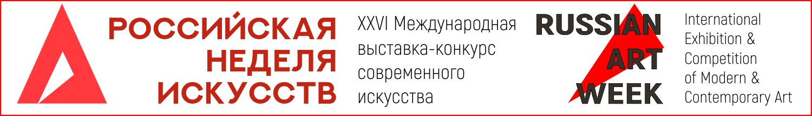
(Moscow, November 1-6, 2019)

APPLICATION FORM / individual
INFORMATION ABOUT ARTIST
Full name
Email
Mobile phone number
Additional phone number
Skype
Mail Address
Zip code / index
INFORMATION ABOUT ARTIST ON THE INTERNET
Personal web site:
Social networks: |  | Facebook:  VKontakte:  Instagram:  Twitter:  Other:
Links to sites where atist’s artworks are published:
FORM OF PARTICIPATION
IN ABSENTIA ___  IN PERSON ___ |  |  |  | 1. Participation in the exhibition&competiiton (in person) ___  2. Participation in the exhibition&competition (in absentia) ___  3. Participation in the exhibition&fair (without contest) ___  4. Participation on the conference (in person) ___  5. Participation on the conference (online) ___  6. Space for installations ___
Member of creative unions ___
Professional ___
Student ___
Amateur ___
Membership in artistic unions (list titles, regalia, positions)
INFORMATION ABOUT THE WORKS THAT YOU PRESENT AT THE EXHIBITION
№ | Title |  | DIMENSIONS (Height*Width) |  | USED TECHNIQUES | YEAR
1
2
3
4
5
By sending the completed application form, I give permission to the Organizing Committee of the International Exhibition-Competition of Contemporary Art “Russian Art Week” (hereinafter referred to as the “Competition”) for informational purposes, in order to ensure the holding of the Competition and creation and distribution of a catalog and to collect, record, organize, accumulate , store, clarify (update, modify), retrieve, use, transfer (including entrust processing to other persons), de-identify, block, delete, destroy - my personal data First names, last name, middle name, mobile, work phone number, date, year and place of birth, address, email address, Skype, addresses on social networks. I also give permission to the Organizing Committee of the Competition in order to inform about new developments in the field of art, competitions, special offers, catalogs, master classes, lectures, round tables to process the above personal data and send information from above to my email address and / or mobile phone number. The consent may be withdrawn by me at any time by sending a written notice to the address: 119049, Moscow, Krymsky Val street 8/2, 352-5 office.

Date of filling in: Name of the filling person:
Label for art object:

Artist name:  TITLE:  DIMENSIONS (Height* Width)  TECHNIQUES:  YEAR OF CREATION: |  |  |  | Number (assigned by the organizing committee):
Competition: | Nomination: | Professional category: | Price (in Russian rubles):
The idea of competitive work (up to 100 words):

Artist name:  TITLE:  DIMENSIONS (Height* Width)  TECHNIQUES:  YEAR OF CREATION: |  |  |  | Number (assigned by the organizing committee):
Competition: | Nomination: | Professional category: | Price (in Russian rubles):
The idea of competitive work (up to 100 words):

